PHASE -2 PROJECT ON **INNOVATION** OF STOCK PRICE PREDICTION.

* **MY INNOVATION FOR MY PROJECT (introduction):-**

**Innovation in stock price prediction is an ongoing and evolving field, driven by advancements in technology, data availability, and machine learning techniques. Here are some innovative approaches and technologies that have the potential to improve stock price prediction:**

**1. **Deep Learning Models:** Utilize advanced neural network architectures, such as Transformer-based models (e.g., GPT-3 or its successors), to capture complex patterns in financial data and news sentiment. These models can potentially provide more accurate and nuanced predictions.**

**2. **Reinforcement Learning:** Apply reinforcement learning techniques to create autonomous trading agents that learn and adapt strategies based on historical data. These agents can make real-time decisions to optimize trading outcomes.**

**3. **Quantum Computing:** Explore the potential of quantum computing to handle complex calculations and simulations involved in stock price prediction. Quantum algorithms may significantly speed up optimization processes and improve predictive accuracy.**

**4. **Natural Language Processing (NLP):** Enhance sentiment analysis by using state-of-the-art NLP models like BERT or RoBERTa to analyze news articles, social media posts, and earnings reports for market sentiment and impact assessment.**

**5. **Alternative Data Sources:** Incorporate non-traditional data sources, such as satellite imagery, social media activity, or web scraping data, to gain unique insights into market trends and make more informed predictions.**

**6. **Explainable AI (XAI):** Develop models that provide interpretable explanations for their predictions. This can help traders and investors understand the reasoning behind stock price forecasts and build trust in AI-driven insights.**

**7. **Ensemble Learning:** Combine predictions from multiple models, possibly using techniques like stacking or boosting, to leverage the strengths of different algorithms and improve overall accuracy.**

**8. **Real-time Data Processing:** Implement real-time data pipelines and streaming analytics to process incoming data feeds quickly. This enables timely updates to predictions and trading strategies.**

**9. **Graph Analytics:** Analyze financial networks and relationships between companies, industries, and investors using graph analytics. This can reveal hidden dependencies and predict market movements more accurately.**

**10. **Interdisciplinary Approaches:** Collaborate with experts in finance, economics, and behavioral psychology to integrate economic indicators, market sentiment analysis, and human behavior modeling into your prediction framework.**

**11. **Ethical AI and Bias Mitigation:** Prioritize ethical considerations, fairness, and bias mitigation in your prediction models, especially when making decisions that affect financial markets and investors.**

**12. **Blockchain Technology:** Leverage blockchain for transparent and secure data storage and transaction history. This can help ensure data integrity and provide auditable records for regulatory compliance.**

**13. **Quantitative Behavioral Finance:** Combine behavioral economics and finance to model and predict how human behavior influences financial markets, taking into account psychological biases and sentiment fluctuations.**

**14. **Decentralized Finance (DeFi) Data:** Incorporate data from decentralized finance platforms to gain insights into emerging trends and liquidity shifts in the cryptocurrency and blockchain space.**

**15. **Experiential Learning:** Explore online competitions and hackathons focused on financial prediction tasks, such as those hosted by platforms like Kaggle. Participating in these events can expose you to cutting-edge techniques and datasets.**

**Innovation in stock price prediction requires a multidisciplinary approach, a commitment to staying updated with the latest research, and a willingness to experiment with new technologies and data sources. Keep in mind that while these innovations can enhance prediction accuracy, they should be used with caution, and risk management strategies should always be in place when making investment decisions.**

**Process:-**

**Creating a stock price prediction model involves several steps, from conceptualizing the design to implementing and deploying the model. Below, I'll outline a detailed step-by-step process for building a stock price prediction model:**

1. **Problem Definition and Data Collection**
2. **Data Preprocessing**
3. **Exploratory Data Analysis (EDA)**
4. **Data Splitting**
5. **Model Selection**
6. **Model Training**
7. **Model evaluation**
8. **Model Testing and model deployment**
9. **Maintenance**
10. **Documentation**

**These are the following steps involved in my design thinking…**

* **DATASET :-**

**I took the dataset from(**[**www.kaggle.com/data**](http://www.kaggle.com/data)**).**

**The dataset is related to STOCK PRICE PREDICTION.**

**The example dataset contains the MICROSOFT HISTORICAL DATASET stocks from 13/03/1986 to 08/01/2020 .**

**MY DATASET LINK:**

**(https://www.kaggle.com/datasets/prasoonkottarathil/microsoft-lifetime-stocks-dataset)**

* **Details of my dataset:-**

**In my dataset the column names contains:**

**I)date – from 1986 to 2020**

**ii)Open – open rate**

**III)High – high percent**

**iv)low – low percent**

**v)Close -closest to peak**

**vi)AdjClose – nearby**

**vii)Volume – size of data**

**for eg: (☹flowchart):**

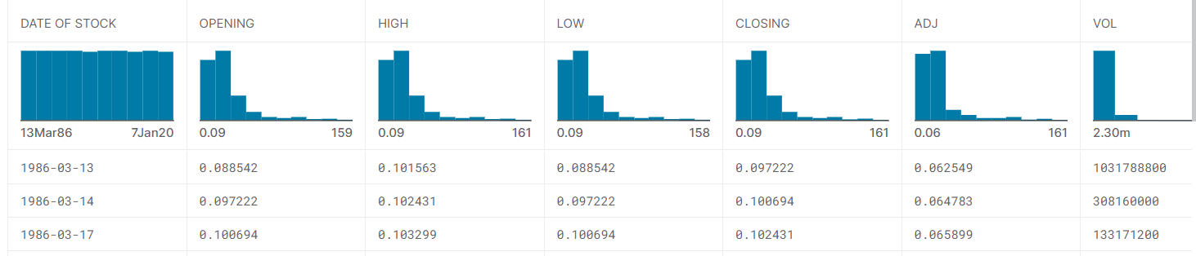

* **How to work ?**

**How to import datasets?**

import pandas as pd

# Replace 'your_dataset.csv' with the actual path or URL to your dataset

dataset_path = 'your_dataset.csv'

# Read the dataset into a pandas DataFrame

df = pd.read_csv(dataset_path)

# Display the first few rows of the dataset to verify that it was read correctly

print(df.head())

**code:**

Import matplotlib.pyplot as plt

From sklearn.datasets import make_blobs

From sklearn.cluster import kmeans

#generate synthetic dataset with 4 clusters

X,y=make_blobs(n_samples=40, cluster_std=1.0, random_state=42)

Print(x)

Print(y)

To plot:

Plt.scatter(x[:, 0], x[:,1], s=50)

Set title:

Plt.title(“My data”)

Plt.xlabel(“feature1”)

Plt.ylabel(“feature2”)

Plt.legend()

Plt.show() -----used to plot graph

* **Code to develop bar chart for performing dataset:-**

pip install matplotlib

import pandas as pd

import matplotlib.pyplot as plt

# Load the Microsoft historical dataset into a pandas DataFrame (replace 'your_dataset.csv' with the actual dataset path)

df = pd.read_csv('your_dataset.csv')

# Assuming the dataset has a 'Date' column and a 'Close' column for closing prices

# You can modify the column names based on your dataset structure

dates = pd.to_datetime(df['Date'])

closing_prices = df['Close']

# Create a bar chart

plt.figure(figsize=(12, 6))

plt.bar(dates, closing_prices, color='b', alpha=0.7, label='Closing Prices')

plt.xlabel('Date')

plt.ylabel('Closing Price')

plt.title('Microsoft Stock Closing Prices Over Time')

plt.legend()

plt.grid(True)

# Rotate x-axis labels for better readability

plt.xticks(rotation=45)

# Display the bar chart

plt.tight_layout()

plt.show()

* **How to test and train dataset?**

**pip install scikit-learn ----install it**

**import pandas as pd**

**from sklearn.model_selection import train_test_split**

**df = pd.read_csv('your_dataset.csv') --loading dataset**

**# Define your features (X) and target variable (y)**

**#Replacing columns**

**feature_columns = ['feature1', 'feature2', ...]**

**target_column = 'target'**

**X = df[feature_columns]**

**y = df[target_column]**

**# Split the dataset into training and testing sets (e.g., 80% training, 20% testing)**

**# You can adjust the test_size parameter to change the split ratio**

**X_train, X_test, y_train, y_test = train_test_split(X, y, test_size=0.2, random_state=42)**

**# Optionally, you can also split your data into validation sets if needed**

**# X_train, X_val, y_train, y_val = train_test_split(X_train, y_train, test_size=0.2, random_state=42)**

**(The changes on stock will be viewed with help of the below bardiagram)**

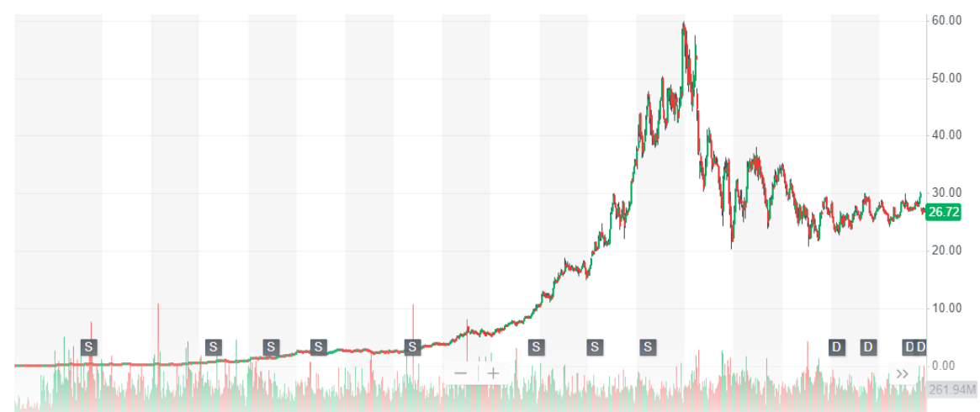

* **Metrics used for accuracy check:-**

**For Classification Tasks (e.g., binary or multiclass classification):**

1. **Accuracy:** This is a widely used metric that calculates the ratio of correctly predicted instances to the total number of instances. It's suitable for balanced datasets. However, it may not be the best choice for imbalanced datasets, where a class is significantly more prevalent than others.
2. **Precision:** Precision measures the ratio of correctly predicted positive instances to the total predicted positive instances. It's valuable when minimizing false positives is crucial, such as in spam detection or medical diagnosis.
3. **F1-Score:** The F1-score is the harmonic mean of precision and recall. It provides a balance between precision and recall and is useful when there's an uneven class distribution.

**For Regression Tasks (e.g., predicting numerical values):**

1. **Mean Absolute Error (MAE):** MAE calculates the average absolute difference between the predicted values and the actual values. It is less sensitive to outliers compared to RMSE.
2. **Mean Squared Error (MSE):** MSE calculates the average of the squared differences between predicted and actual values. It penalizes larger errors more heavily than MAE.
3. **Root Mean Squared Error (RMSE):** RMSE is the square root of MSE and provides an interpretable measure of prediction error in the same units as the target variable. It's sensitive to outliers.